# Capillary Pressure Model

Andy May (10/2/2013)

The capillary pressure model is based entirely upon special core analysis. Following is a description of the model. The model has two purposes, one is a check on the resistivity based Sw calculations and the other is to show which of the reservoirs in your field fit particular contacts (check reservoir continuity).

The free-water level (FWL) used in these calculations is generally below the hydrocarbon-water contact in water-wet reservoirs.

The principle references are:

Brooks and Corey, 1966, Properties of Porous Media Affecting Fluid Flow, Journal of the Irrigation and Drainage Division, Proceedings of the American Society of Civil Engineers.

Amaefule, Kersey, Marschall, Powell, Valencia, and Keelan, 1988, Reservoir Description: A Practical Synergistic Engineering and Geological Approach Based on Analysis of Core Data, SPE 18167.

Firoozabadi & Ramey, 1988, Journal of Canadian Petroleum Technology, vol. 27, no. 3.

## Swe\* vs Capillary Pressure

Swe\* is different from the from the log analysis Swe. The log analysis Swe is computed using only Sw (the total Sw) and Swb (the shale bound water saturation, or Phish\*Vsh/Phit) and only has the shale-bound water removed. The Capillary Pressure Swe\* has all of the shale-bound water plus the capillary bound water removed, it is defined by:

Corey_Pb

Eq. 1

Where: Pb is the “bubbling” pressure. This is the pressure (in drainage mode) where hydrocarbon permeability begins. That is, the pressure at which hydrocarbon first flows from one end of the core plug to the other as water is drained from the plug.

Pc is capillary pressure, defined by:

pc

Eq 2

Where: ρw is the density of water and ρh is the density of the hydrocarbon. H is the height above the free-water- level. It is also true that:

Eq Corey_Sw_from_Sr3

And, as Amaefule, et. al. 1988 showed:

Swe_J_J100

Eq 4

## J Function

J100 is the J factor at the bubbling pressure and J is the J factor at a particular capillary pressure. J is defined as:

J

Eq 5

Theta (θ) is the contact angle. If the relative permeability measurements clearly indicate that the rock is water-wet, we can safely assume that Theta=0. Sigma (σ) is the interfacial tension and correlations (Firoozabadi & Ramey, 1988, Journal of Canadian Petroleum Technology, vol. 27, no. 3, p. 41) can help you determine values to use for most hydrocarbon reservoirs, it is in dynes/cm. Capillary pressure is denoted as Pc, permeability as k, and porosity is denoted as ø.

Thus to complete Equation 3 and compute Swcp (Sw from capillary pressure) we need to obtain values for Sr (total irreducible water), J100, and lambda(λ). The following illustrations show how this is done. Figure 1 shows how Sr is computed from Rmh and Figure 2 shows how lambda and J100 are computed.



**Sr**



Figure 1: Rmh versus Sw(irreducible) crossplot

By assuming that the maximum capillary pressure from the porous plate measurements drives them down to irreducible water saturation (Sr) we can plot Rmh versus this Sr and construct a function to compute Sr from Rmh. That function is shown above. Sr is required to compute Swe\*, from which we can get lambda and J100.



λ = 1.827

J100 = 0.31

Lamda (λ) is the negative of the slope



Figure 2: Swe\* versus J crossplot

Lambda is the negative of the slope of the dominant line of the points. J100 is the J at the bubbling pressure. The bubbling pressure is nearly always over 90% Swe\*, so picking it is quite easy.

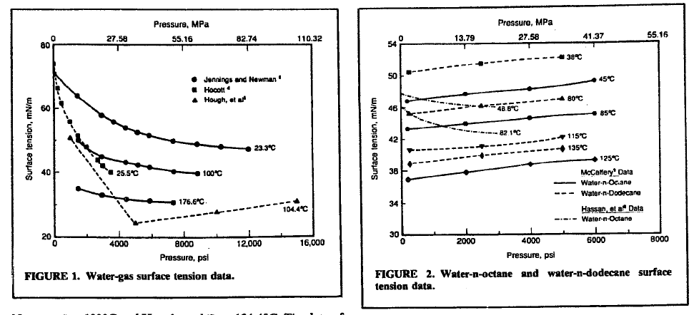

For gas use the above charts from Firoozabadi, 1988 to get sigma. Delta-rho can be determined from fluid samples.